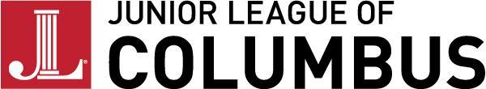

ENABLING FUND GRANT APPLICATION

Date of Application:

Name of Organization:

Project/Program for which funds are requested:

Contact Person:

Address:

Phone: Email:

Website:

Amount Requested:

Please respond fully to the following:

Please describe your organization’s purpose or mission:

What is the critical need to be addressed by an Enabling Fund Grant? Please indicate how this project/program aligns with the JLC focus on women and children.

When will the funds be put to use?

What is the anticipated total budget for this project/program?

Please list other prospective funding sources solicited for this project/program.

Please attach a copy of your organizations 501(c)(3) authorization letter and send form to:

Enabling Fund Chairman
Junior League of Columbus
1240 Wynnton Road
Columbus, GA 31906

The Junior League of Columbus is an organization of women committed to
promoting voluntarism, developing the potential of women and improving
communities through the effective action and leadership of trained volunteers.
Its purpose is exclusively educational and charitable.

